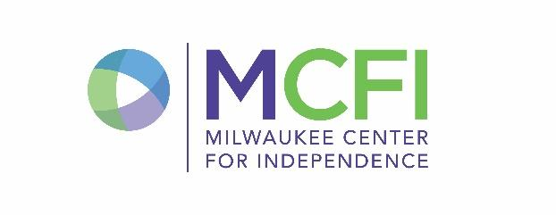
St. Marcus North Campus
MARCH 2023
MCFI
CACFP Breakfast

MONDAY | TUESDAY | WEDNESDAY | THURSDAY | FRIDAY
MILK FOR SCHOOL:  *water is always a choice  SKIM WHITE  LOW FAT WHITE  SKIM CHOCOLATE  MENU SUBJECT TO CHANGE |  | 1  WG Vanilla Honey Bunches of Oats Cereal Bowl  Seasonal Breakfast Fruit  Choice of Milk | 2  WG Apple Cinnamon Muffin  Seasonal Breakfast Fruit  Choice of Milk | 3  WG Raisin Bran Cereal Bowl  Seasonal Breakfast Fruit  Choice of Milk
6  WG Cinnamon Goldfish Graham  Strawberry Banana Yogurt  Choice of Milk | 7  WG Crunchmania - Cinnamon Bun  Seasonal Breakfast Fruit  Choice of Milk | 8  WG Honey Cheerios Cereal Bowl  Seasonal Breakfast Fruit  Choice of Milk | 9  Apple Cinnamon Spread  WG Honey Grahams  Seasonal Breakfast Fruit  Choice of Milk | 10  WG Blueberry Bread Slice  Seasonal Breakfast Fruit  Choice of Milk
13  WG Cherry Apple Dunker Bar  Seasonal Breakfast Fruit  Choice of Milk | 14  Creamy Chickpea Spread  WG Animal Cracker  Seasonal Breakfast Fruit  Choice of Milk | 15  WG Cinnamon filled Mini Bagel  Seasonal Breakfast Fruit  Choice of Milk | 16  WG Corn Chex Cereal Bowl  Seasonal Breakfast Fruit  Choice of Milk | 17  Vanilla Yogurt Cup  WG Vanilla Bear Crackers  Seasonal Breakfast Fruit  Choice of Milk
20  WG Cinnamon Bread Slice  Seasonal Breakfast Fruit  Choice of Milk | 21  WG Maple Waffle Crackers  String Cheese  Seasonal Breakfast Fruit  Choice of Milk | 22  WG Cheerios Cereal Bowl  Seasonal Breakfast Fruit  Choice of Milk | 23  WG Cinnamon Chex Cereal Bowl  Seasonal Breakfast Fruit  Choice of Milk | 24  NO SCHOOL
27  WG Banana Bread Slice  Seasonal Breakfast Fruit  Choice of Milk | 28  WG Vanilla Bear Crackers  Seasonal Breakfast Fruit  Choice of Milk | 29  WG Triple Berry Dunker Bar  Seasonal Breakfast Fruit  Choice of Milk | 30  WG Multigrain Cheerios Bowl  Seasonal Breakfast Fruit  Choice of Milk | 31  WG Cinnamon Flakes Cereal Bowl  Seasonal Breakfast Fruit  Choice of Milk
2/13/2023

